Sujal Pawar (EXCS)

Cloud Computing Practical Examination

Total Marks: 40

Duration: 60 Minutes Instructions
- Perform all tasks on your own cloud virtual machine.
- You may use AWS EC2, GCP Compute Engine VM, or Azure Virtual Machine.
- Attach screenshots as evidence of completion.
- Create a single PDF containing all screenshots and answers.
- Mention question numbers clearly.
- Ensure all screenshots clearly show successful execution of commands.
- Look at the end of the pdf for submission instructions

Question 1: Docker Installation & Nginx Deployment

Task
- Install Docker on your cloud virtual machine.
- Verify Docker installation.
- Download the Nginx image.
- Run the Nginx container.
- Access the Nginx welcome page from your browser.

Required Screenshots
- Docker version output ● Docker images output
- Docker ps output showing Nginx running
- Browser showing "Welcome to nginx!"

Hint
Relevant Docker topics:
- Images
- Containers
- Port Mapping
- Container Lifecycle

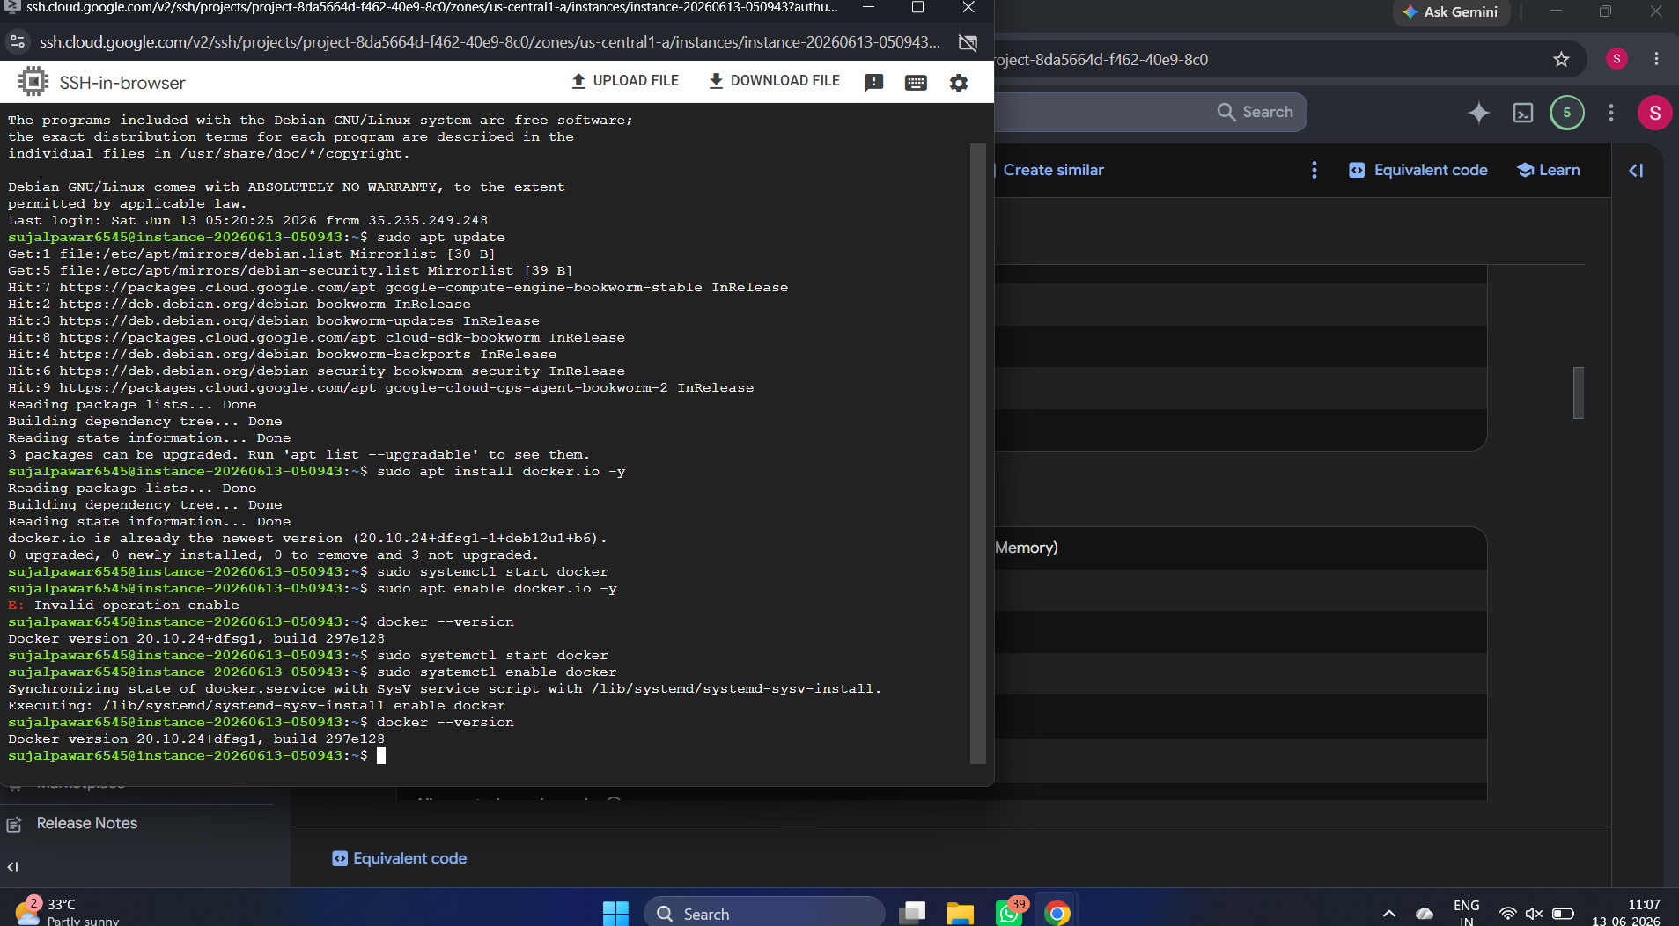

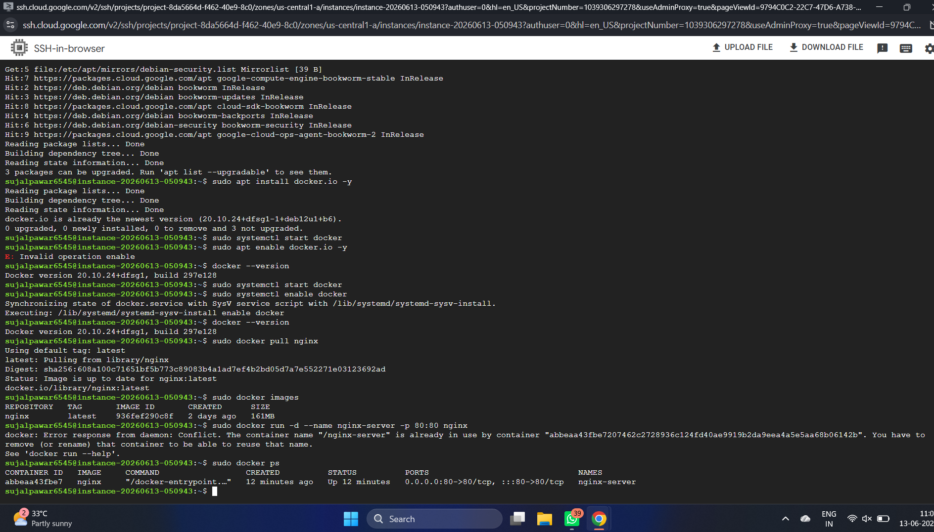

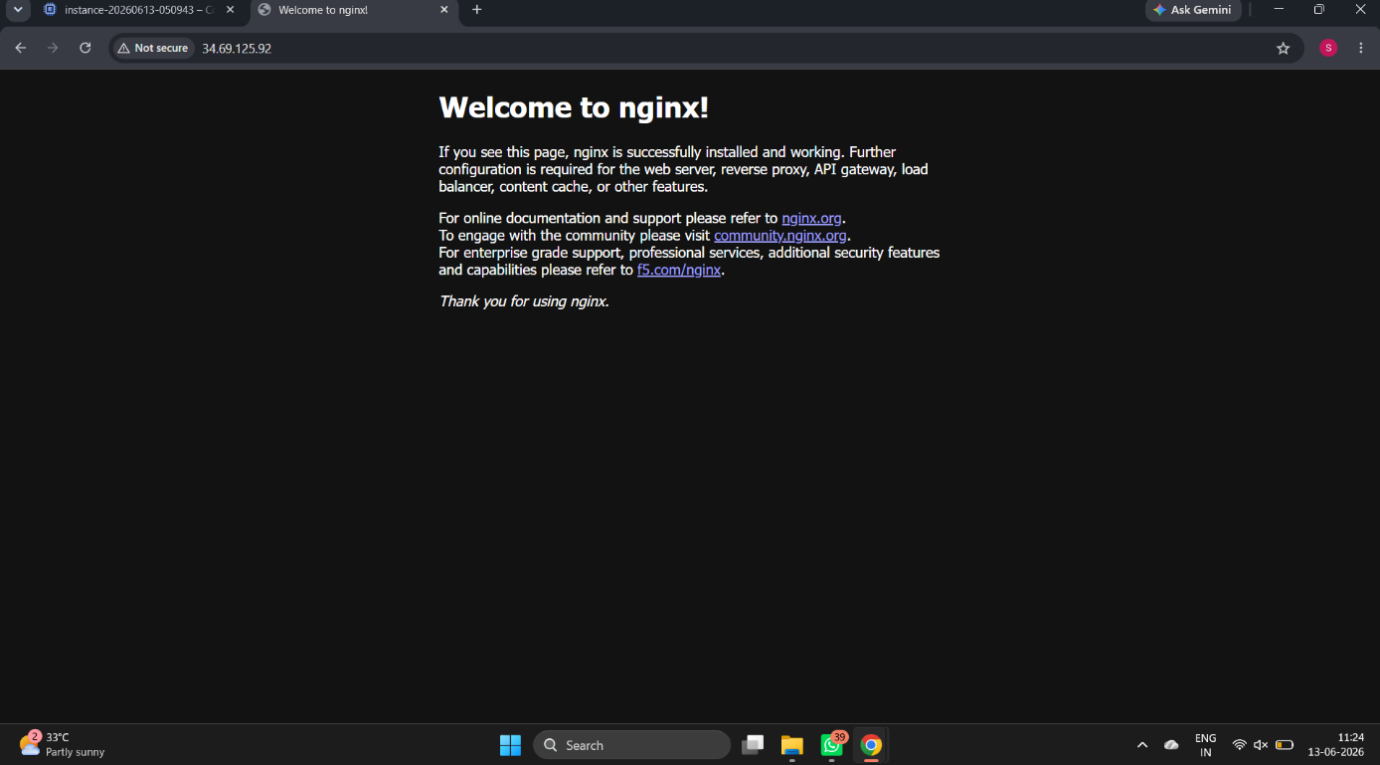

Question 2: Docker Volume Practical

Task
- Create a Docker volume named: studentdata
- Run an Ubuntu container using the volume.
- Create a file: /data/info.txt
- Write your name and roll number inside the file.
- Display the contents of the file.

Required Screenshots
- Volume creation
- Running container
- File creation
- File contents displayed using cat

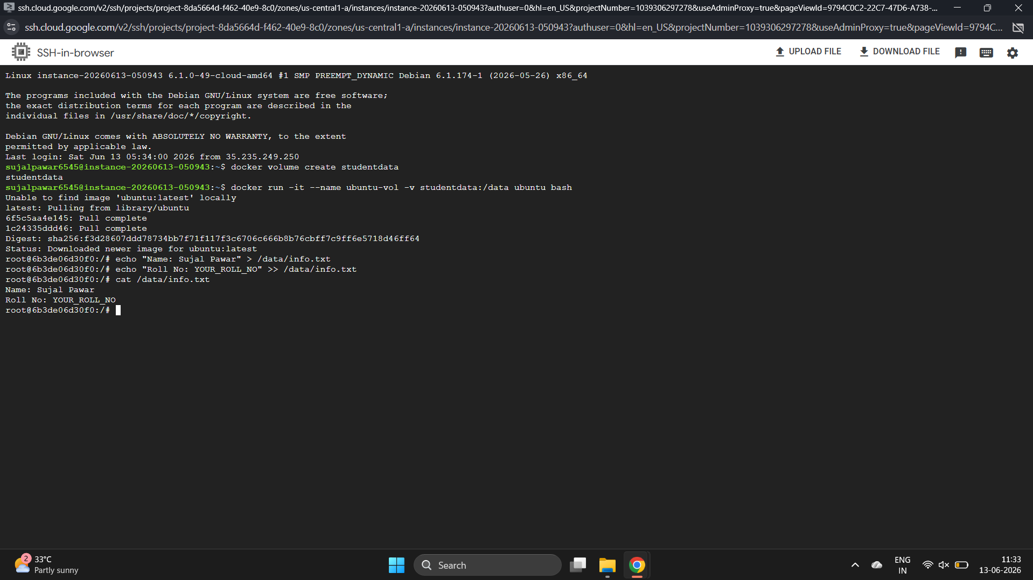

Question 3: Build Your First Docker Image

Task
Create a custom Docker image that displays the following message when executed:
Cloud Computing Practical Exam Completed Successfully Build the image and run it successfully.

Required Screenshots
- Dockerfile
- docker build output
- docker images output
- docker run output

Hint
Relevant Dockerfile keywords:
- FROM
- CMD
- COPY
Think about:
- Which base image should be used?
- How does Docker know what command to execute when the container starts? ● When would COPY be useful while building an image?
- 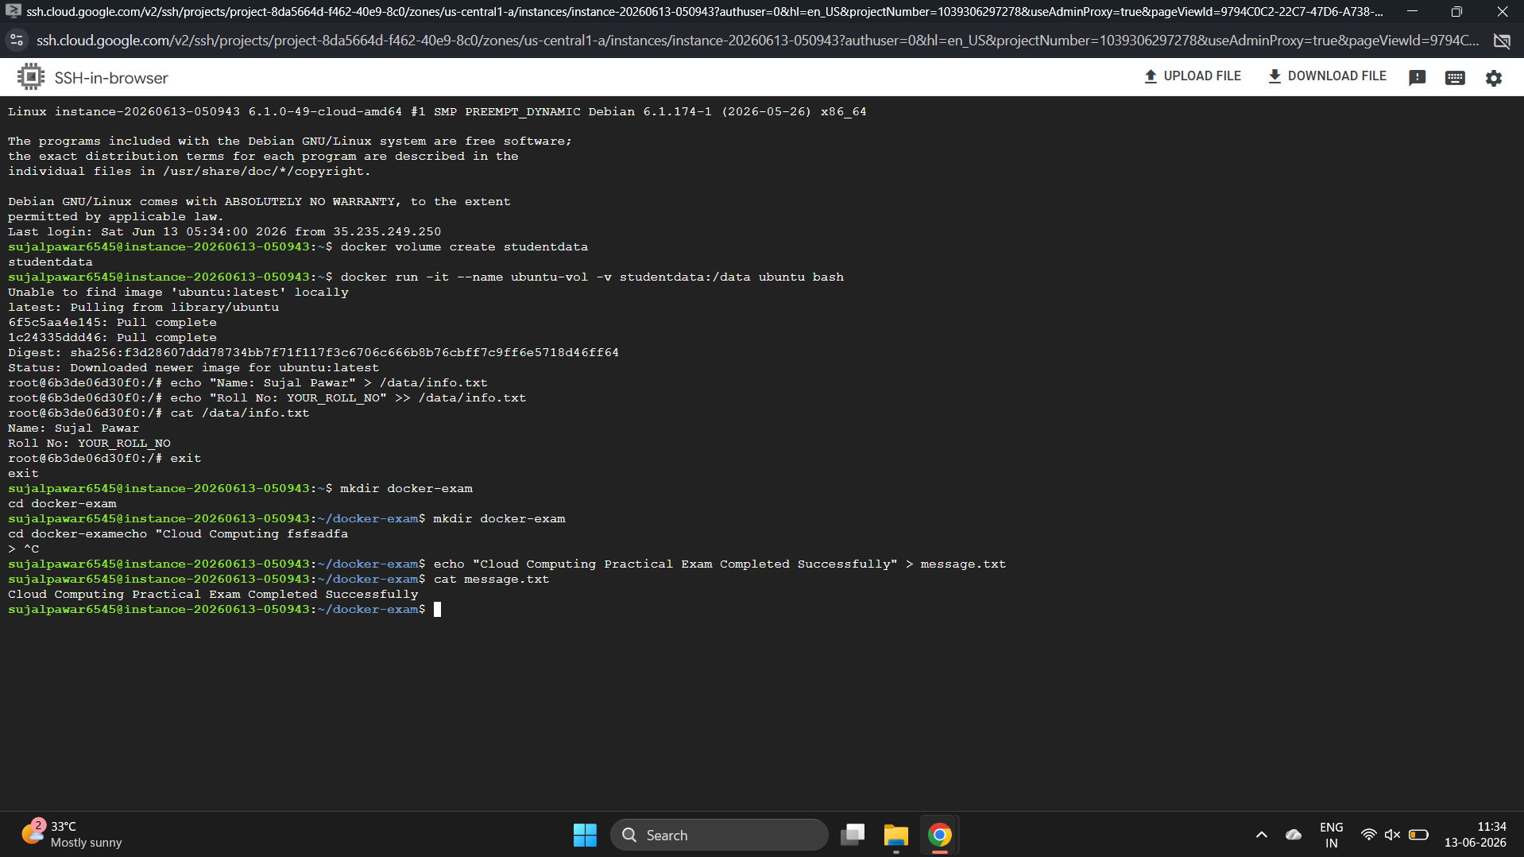

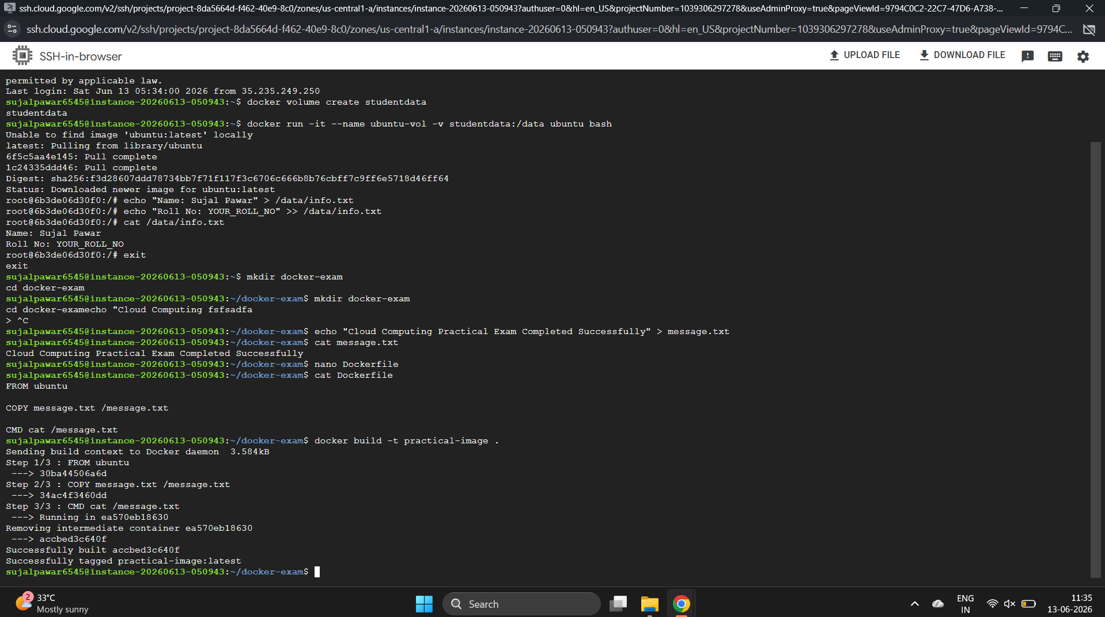

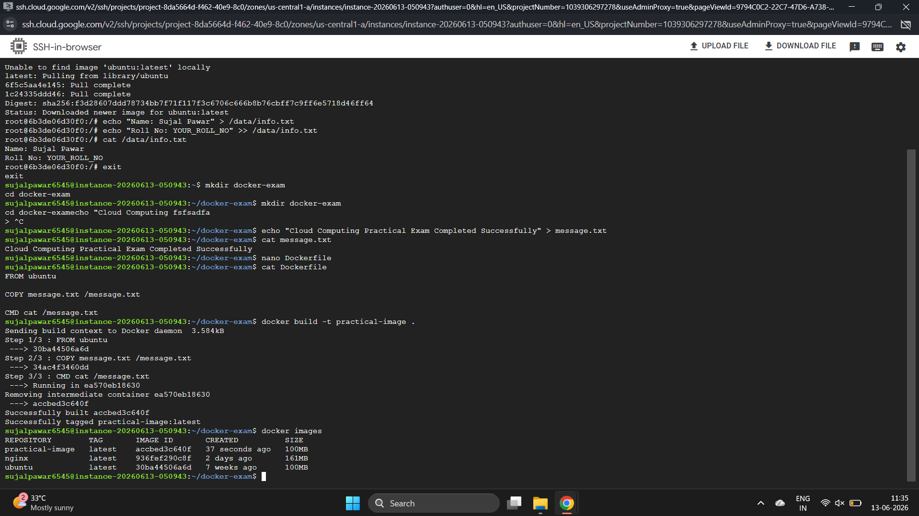

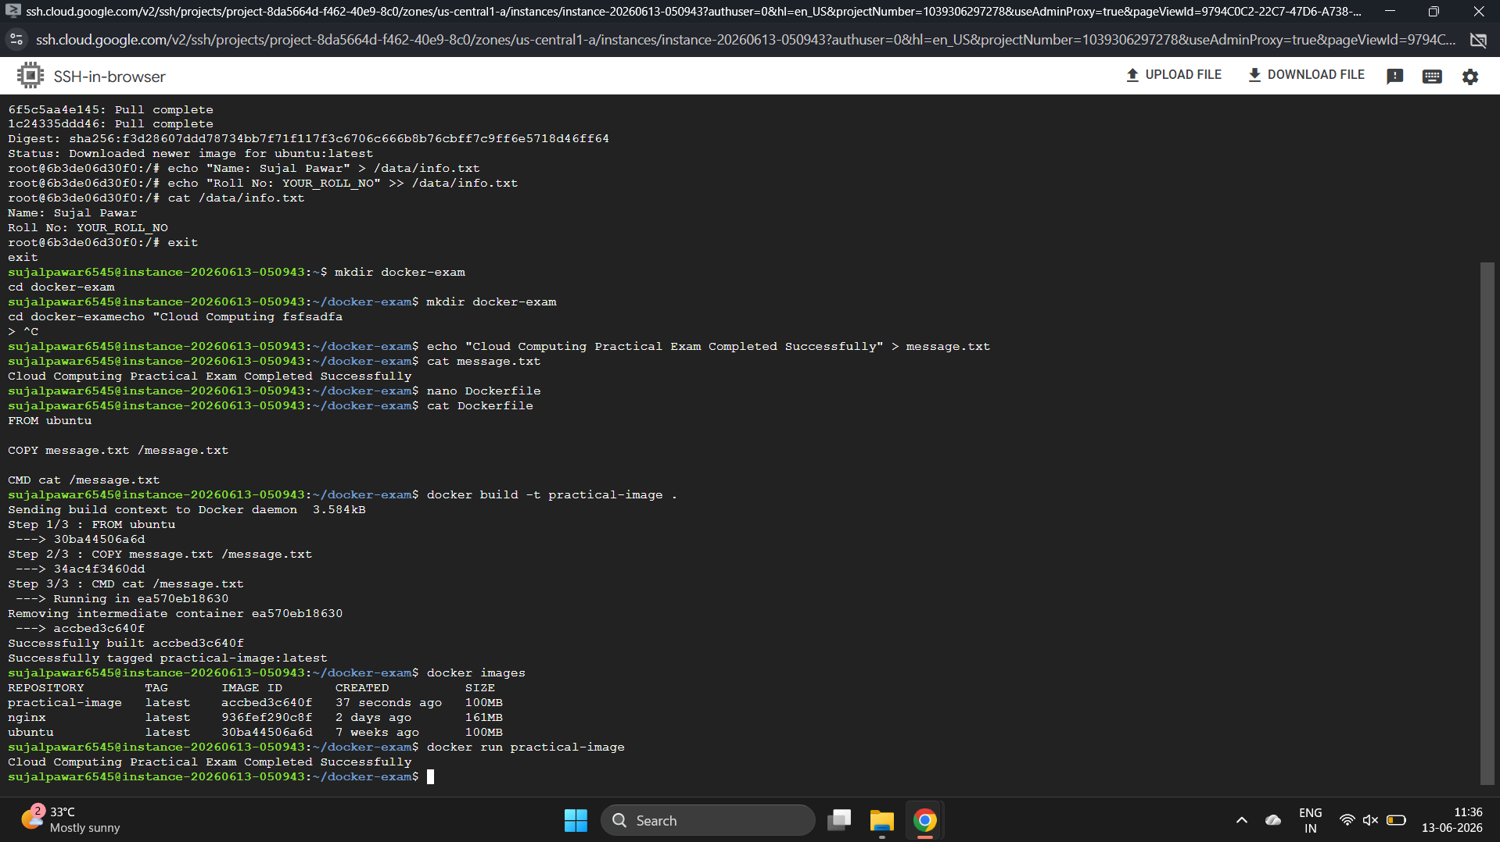

Bonus Challenge (Optional)
Explain in 2–3 lines each:
- Difference between a Docker Image and a Docker Container.
- Why are Docker Volumes used?

Submission Checklist
☐ Docker Installation Verification
☐ Nginx Running Successfully
☐ Browser Access to Nginx
☐ Docker Volume Creation
☐ File Creation and Verification
☐ Custom Docker Image Build
☐ Custom Docker Container Execution
☐ Bonus Questions (Optional)

Submission Instructions
After completing the practical examination:

Step 1: Create a PDF
Combine all screenshots and answers into a single PDF document.

Naming Convention
studentname_id_branch.pdf Example:
ImranSayyed_12345_CSE.pdf

Step 2: Repository Information
Repository:
https://github.com/sayyedimran2599/azure-services
Submission Branch:
practical_exam

Step 3: Switch to Submission Branch
If the branch is not already available locally, fetch the latest branch information from GitHub.
Switch to the branch:
practical_exam

Step 4: Copy Your PDF
Place the completed PDF inside the repository folder.
Verify that the PDF is visible inside the repository.

Step 5: Commit Message Format
Use the following format:
Name_ID_Q1Q2Q3
Examples:
ImranSayyed_12345_Q1Q2Q3
AishwaryaYadav_67890_Q1Q2
RahulPatil_54321_Q1
Where:
Q1Q2Q3 = All questions attempted
Q1Q2 = Questions 1 and 2 attempted
Q1 = Only Question 1 attempted

Step 6: Push Your Submission
Push your changes to the:
“practical_exam” branch.

Step 7: Verify Submission
Verify that:
- Your PDF is present in the repository.
- Your commit message follows the required format. ● The file is visible in the practical_exam branch.
Your submission is considered complete only after the PDF is successfully pushed to GitHub.

